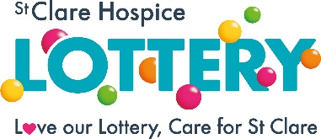
SELF EXCLUSION FORM

If you feel you have a problem with gambling and would like to request that St Clare Hospice excludes you from playing their lottery and from all other gambling activities, you can simply complete and return the form below, by post or by email.
Membership number (if known) _________________________
Name _____________________________________________
Address ___________________________________________________________
Postcode __________________________________________________________
Telephone number _______________________
Email address: ________________________________________

I wish to be excluded immediately from St Clare Hospice Lottery for a period of: ___________months (please state chosen period, minimum 6 months, maximum 12 months)

I understand that I will not be allowed to rescind my self-exclusion during this period.

I understand that if I make my payments by Standing Order, I must cancel this at my bank, as St Clare Hospice is unable to do this on my behalf.

I acknowledge my responsibility in ensuring adherence to this agreement. I acknowledge that the Promoter, its employees or agents have no liability or claims arising from my voluntary use of the gambling facilities provided.

Following our successful completion of your self-exclusion request:
- Your chosen self-exclusion period will remain in force with St Clare Hospice, for the minimum period as chosen above
- St Clare Hospice will not send you any gambling related marketing materials, unless and until you specifically request us to do so
- You will not be entered into any further lottery draws, and any outstanding credit on your lottery account will be refunded to you.

Signature:_________________________________________________________
Print Name: _______________________________________________________
Date: __________________________________

Please ring St Clare Hospice Lottery on 01279 773717, if you wish to discuss this request confidentially, or if you wish to extend your chosen self-exclusion period (minimum 6 months extension).
We recommend that you consider extending your self-exclusion to other gambling premises in your area.

If you feel you have a problem with gambling visit www.begambleaware.org, or call the
National Gambling Helpline on 0808 8020 133.

